MatheMagic Online

Screen Shots:

Showing LOGIN, SOLVE, LIST, LOGOUT commands functioning. And returning error message if input in invalid.

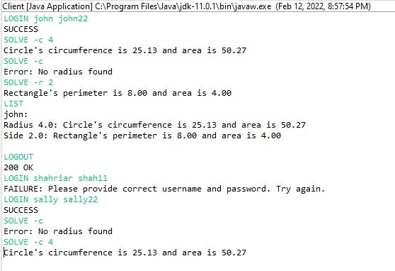

Invalid command:

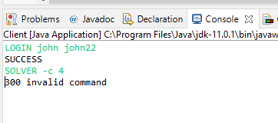

Shutdown command:

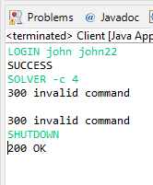

Showing all the commands including root, LIST -all

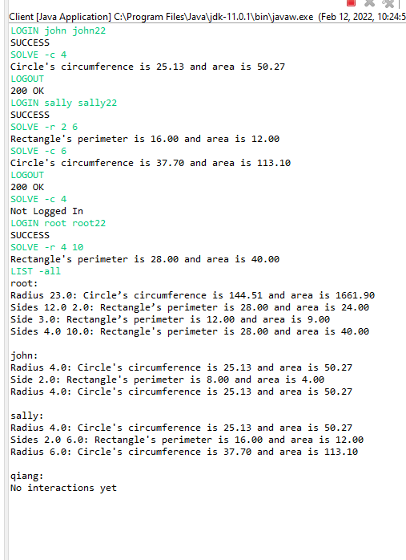

If the user is not root:

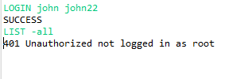

Multiple clients running simultaneously:

Sending message to a client to see if the other client receives the message or not:

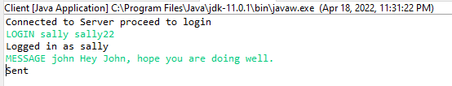

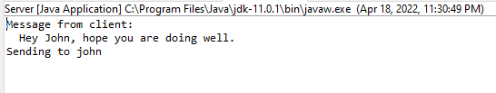

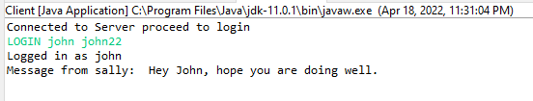

Sending message to someone who is not logged in will return error:

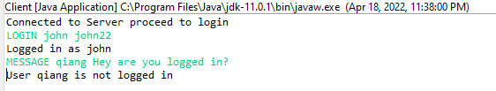

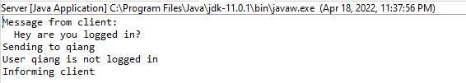

Sending message without log in returns error: John is sending message to sally. Sally is not logged in.

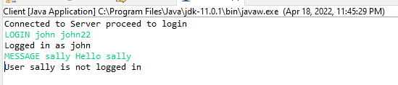

Sending message to all clients who are logged in from root.

